Moving for Change Network Membership Application Form
Moving for Change is committed to protecting your data and privacy in accordance with the provisions of the Data Protection Act 1998 and the General Data Protection Regulation (GDPR) 2018. Any information you provide as part of the application process will be stored safely, kept completely confidential and only used for the purpose of assessing membership readiness.
If you are handwriting your application, please ensure you print your responses.
Section A: Membership Categories
Q1. Which of the following categories do you fall into (please tick one box):
Category | Please tick the appropriate box
1. Individual/freelancer
2. Micro group (annual turnover/income of less than £25k)
3. Small organisation (annual turnover/income of £25k to 150k)
4. Medium to large-sized organisation (annual turnover/income of more than £150k)
5. Key Partner Agency such as a University or Local Authority

If you indicate Category 1 (individual/freelancer), please complete Section B. All other applicants should go directly to section C.
Section B: Individual Applicants
If you are applying for network membership as an individual/freelancer, please provide the following contact details:
Q2. Individual Contact Details
Name of individual

Contact address

Email address

Telephone number

Section C: Group/Organisation/Agency Applicants
If you are applying for network membership as a group, organisation or agency, please provide the following contact details (if you are applying as an individual/freelancer, please skip this section and go to section D).
Name of group/organisation/agency

Contact address

Email address

Telephone number

Section D: Commitments
All applicants need to complete this section.
Q3: Are you committed to supporting MfC’s core purpose (please tick the appropriate box)?
Yes
No

Q4: Are you committed to preserving the good name and reputation of MfC (please tick the appropriate box)?
Yes
No

Section E: Areas, insights and interests
All applicants need to complete this section.
Q5. Which countries/regions of the UK do you focus on in terms of your work?
If you operate UK wide, tick the following box and go directly to Question 6:
If you operate in England only, but on a nation-wide basis, tick the following box and go directly to Question 6:

Otherwise, indicate the countries/region(s) in which you operate:
Country/Region | Tick, if covered
1. Scotland
2. Northern Ireland
3. Wales
4. North East
5. North West
6. Yorkshire and the Humber
7. West Midlands
8. East Midlands
9. South West
10. South East
11. East of England
12. Greater London

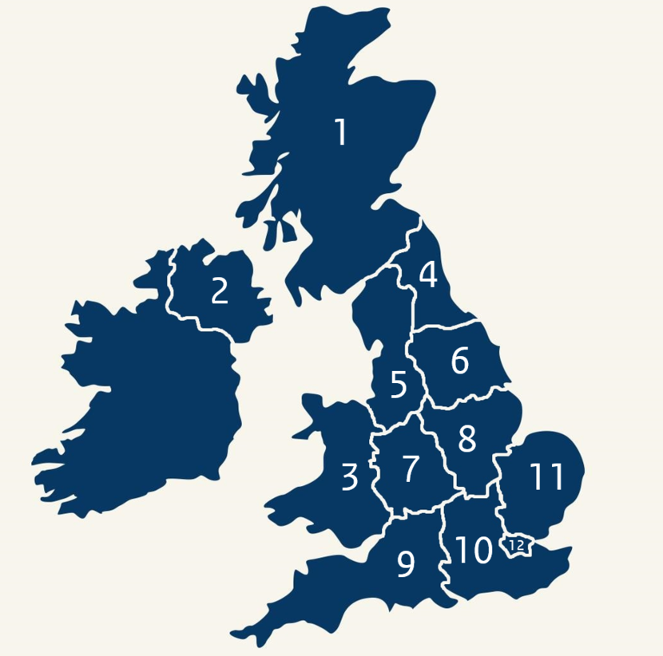
Q6. Please use the box below to describe your practical understanding of the needs and strengths of the Gypsy and Traveller communities you either already work with, or are going to work with:
Maximum 200 words
Q7. Please use the box below to describe your specialist interests/areas of activity in terms of work with Gypsy and Traveller communities:
Maximum 200 words

Declaration
Name of person completing the application form
Email address
Telephone number

I, the undersigned:
- Declare that the information given in this application is true and accurate.
- Understand that, if the application contains any seriously misleading statements (whether deliberate or accidental), or if any information is knowingly withheld, this could make the application invalid.

Signed: Dated:

All completed application forms should be sent to network@movingforchange.org.uk. If you would like any support with filling out an application form, please email on the address above or phone 07873 904 738. Thank you!

Assessment of annual turnover/income should be based on the accounts/financial records for your most recent financial year. If you have only recently started up as a group or organisation, you should estimate what your income is likely to be in the first year of operation.

