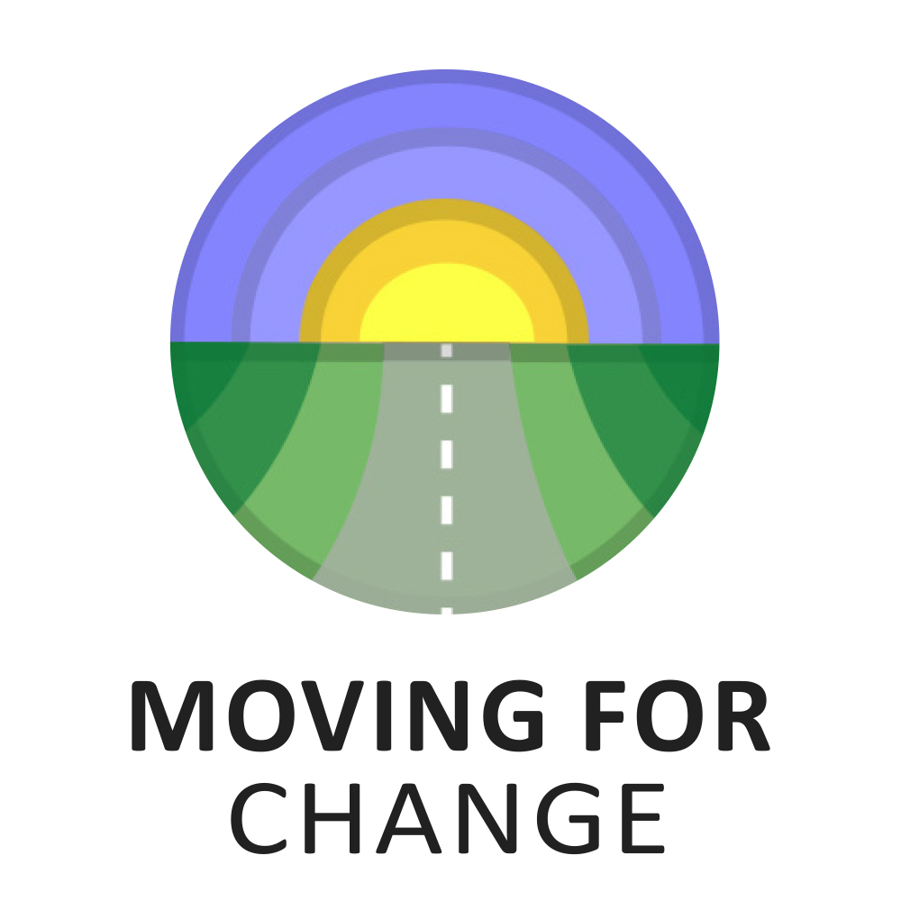

For projects of up to £500

COMMISSIONING AND TENDERING

MICRO PROJECT APPLICATION FORM

application form
Themes for this call:
Moving for Change is looking to fund 20 projects of £500 per project. There are two types of project you can apply for:
1) Celebrating Gypsy, Roma, Traveller History Month, June 2022;
2) ‘My journey to the Fair or Drive’, summer 2022.
Projects for History Month are to fund celebration events during History Month this June. The celebration can take any form you would like, for example an open day on site, a picnic or party day for children.
Projects for ‘My journey to the Fair or Drive’ are to film, photograph or write about your journey to a Fair or Drive this summer. This journey can be to any Drive or Fair including Appleby, St Boswells or any other Fair. The journey must take place between June and August. Funds can be put towards travel.
Who can apply for this funding?
This call is open to Gypsies and Travellers living roadside or on sites. You do not have to be a member of the Moving for Change network to apply [although it would be nice if you did sign up, you can do so here]. The closing date for applications is 25th April 2022 at 5pm and we will let you know the week after the closing date if your application has been successful. If successful, we will ask you for bank details to send the project money to you.
What Moving for Change needs from you
We will ask successful applicants to provide videos and/or images of the funded History Month event. We will ask anyone in the footage to fill out a simple consent form to have their photos shared used by Moving for Change.
For those funded for ‘My journey to the Fair or Drive’ we will ask successful applicants to record a video, audio, picture, or written journal (with photos) of you or your family’s journey to the Fair or Drive. The journal will show your journey to the Fair or Drive, from setting off to getting there as well as taking part in the Fair or Drive. The journal or blog will then be published on the Moving for Change website and social media. We will provide successful applicants with guidance and support on how to do this.
To learn more, you can watch our further information video which can be found at https://youtu.be/A0YE2SPGogA. If you would prefer to fill this form out via phone call, text or WhatsApp, please use this number 07873 904738.

Section 1: Tell us about you

Your name and address:
Name
Address

Post code
Telephone
Email

Independent referee:
Provide details of an independent referee who knows you well enough to give you a character reference.
Name
Organisation
Telephone
Email

Section 2: Tell us about your project
Please tell us which project you are applying for – celebrating History Month or ‘My journey to the Fair or Drive’.
- Celebrating History Month
- ‘My journey to the Fair or Drive’
Tell us about your plans for the project in no more than 500 words. If you prefer you can send us a voice recording or a video for this section you can send this via WhatsApp to 07873 904738.

Section 3: Budget
Please tell us how you would use the £500 if you were successful. Include all the costs.
Costs | Amount from us (£)
Example: Hire of play equipment or travel costs
Total

Section 4: Where did you hear about this funding opportunity?
Please mark an X to all that apply:
- Twitter
- Instagram
- Our website
- Through a friend or family
- Through a colleague
- Through a service or Gypsy, Roma or Traveller organisation
- Search engines such as Google or Bing
- The Travellers Times
- Other- please specify…………………………………………………………………………………………….

Section 5: Declaration
I am applying for £500 which I will spend on the activities I have outlined above in the period of time I have outlined above. I confirm that the information given in this form is true and accurate. I authorise Moving for Change to hold any information supplied about this application in its electronic or manual records and that the information supplied can be used for the purposes of assessment, publicity, or promotion of any award or passed on to other relevant third parties without the need for further consent to be obtained.
Name: | Signature: | Date:

Section 6: Submitting your application
Please send this form to network@movingforchange.org.uk with your name and the project theme you are applying for in the subject line of the email. Please save this form with your name and the project theme as the file name. To apply by phone, text or WhatsApp, please use this number 07873 904738.
You have until April 25th at 5pm to submit your application. Receipt of your application will be acknowledged.

