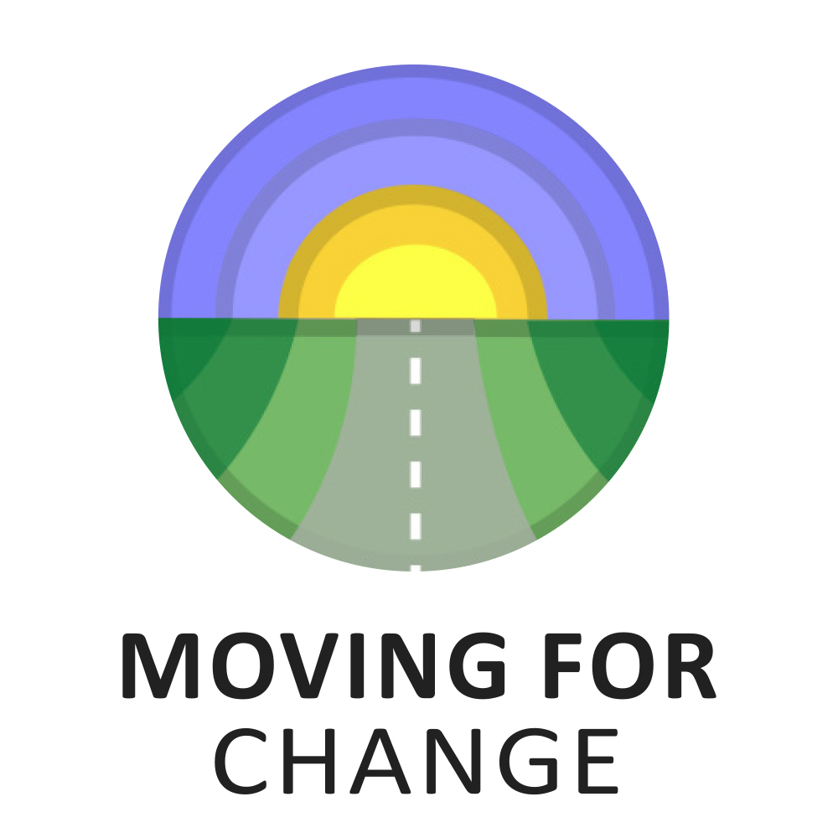

For commissions of £5,000 - £40,000 per annum

COMMISSIONING AND TENDERING

APPLICATION FORM 2022

application form
Themes for this call:
Your project must focus on supporting or raising awareness of Gypsies and Travellers living roadside (for part or all of the year) or those living in insecure accommodation (by this we mean people who do not have access to their own permanent base which they may return to following a period of living roadside/shifting).
This application is for commissioned projects worth £5,000 - £40,000 per annum. You can apply for up to two years of funding, but the total for each year cannot exceed £40,000.
If your application is for existing, co-funded or partnership work, we will expect you to demonstrate how funding from Moving for Change will complement or enhance your work, for example, what will be the added value of our support.
Please refer to the helpsheet and outcome indicators sheet provided when completing this application form. Please make sure that you answer all the questions applicable. Incomplete or late applications will not be considered. Please submit your application no earlier than 9am June 30th and no later than 5pm on Friday August 19th.

Section 1: Tell us about you

1.1 Your name or the name of your organisation:
Name

1.2 Your home address or the registered address of your organisation:
Address 1
Address 2
Address 3
Town
County
Postcode
Country
Telephone
Email address
Website address (if applicable)

1.3 Main contact for this application
Name (if different from above)
Position
Telephone |  | Mobile
Email address

1.4 Bank account details
Name of bank
Account name
Account number
Sort code
Number of signatories

1.5 Independent referee
Provide details of an independent referee who knows the work of your organisation and/or the subject of this application. (If you are applying as an individual you should ask your referee to give you a character reference which also references any previous work you have undertaken with or for nomadic Gypsies and Travellers).
Name
Position
Organisation
Address 1
Address 2
Address 3
Address 4
Town
County
Postcode
Country
Telephone
Email
Relationship to you/ your organisation

Note: If you are applying as an individual you do not need to complete sections 1.6 – 1.13.

1.6 The legal status of your organisation
Legal status
Charity Number |  | Company Number
What year was your organisation established/granted charitable status?
Is your organisation a branch of another charity/body? | Yes/No
If yes, name of parent company/body

1.7 Is your organisation a Social Enterprise? Yes/ No

1.8 Annual income
What was the income of your organisation in its last financial year? (Exclude any income for capital items such as buildings and equipment).
Please mark with an X if you are a new organisation that has been operating for less than one year.

1.9 Geographical area
In which area is your registered office based?

1.10 What are the main aims of your organisation?

1.11 Who are the people involved in your organisation?
How many board members do you have?
How many volunteers are involved?
How many full-time staff are employed?
How many part-time staff are employed?
In the last year, how many people have benefitted from the work of your organisation?

1.12 Describe the makeup of your Board of Trustees. Tell us about the skills and experience of your Board and how you support them.

1.13 What active policies does your organisation have in place that guide your work?

Section 2: Tell us about your project

2.1 Name of project

2.2 Project start date (DD/MM/YYYY) Project end date (DD/MM/YYYY)

2.3 Summarise your proposed project using no more than 500 words.

2.4 Please describe the need or issue that your project will address, including evidence of need.

2.5 How do you know this project will address the need outlined in 2.4?

2.6 Describe how you will work with/involve beneficiaries in shaping the project.

2.7 Will your project have a national or a local remit?
If you will work nationally, how will your project operate on a national basis?
If you will work locally, please list the main local authority areas where the people who will benefit from your projects work, live, or are based.

Section 3: The difference your project will make
Moving for Change’s mission is to improve the quality of life for nomadic Gypsies and Travellers and the communities in which they live across the UK. Our key goals are listed below. To be successful your project should work towards at least one of these goals.

3.1 Please select the goal(s) that your project will work towards by marking X next to all that apply.
1 | Effect positive change in the systems which affect Gypsy and Traveller people's lives and their interaction with the world around them by empowering Gypsies and Travellers to take positive actions to uphold their rights and responsibilities - all with people in the lead.
2 | Support and encourage collaboration between civil society groups in the UK who share an aim to improve the lives of Gypsy and Traveller people.
3 | Co-produce opportunities for members of nomadic communities in the UK to develop innovative projects which, informed by their own lived experience, have potential to improve their lives.

3.2 Project outcomes and activities

Please describe the most important changes or differences for the intended beneficiaries that this project will support. Please note, should your application be successful, you will be required to provide monitoring and evaluation reports which reflect progress towards your outcomes. You can have between one and three goals.

(The help sheet and outcome indicators sheet accompanying this form may be useful for completing this section).

Project outcome 1:
Which Moving for Change goal(s) will this contribute to? | 1☐ 2☐ 3☐
Proposed activities for outcome 1 | Timescales and frequency

Project outcome 2:
Which Moving for Change goal(s) will this contribute to? | 1☐ 2☐ 3☐
Proposed activities for outcome 2 | Timescales and frequency

Project outcome 3
Project outcome 3:
Which Moving for Change goal(s) will this contribute to? | 1☐ 2☐ 3☐
Proposed activities for outcome 3 | Timescales and frequency

3.3 How will you know you are making a difference (e.g. what information/ feedback will you collect and how will you record it)?

3.4 How will your organisation work in partnership with other public, private and third sector organisations to achieve/multiply greater outcomes?

Section 4: Budget
Please complete a separate document for the project budget which gives a detailed breakdown of all costs (per annum if your application is for more than one year). You may use whichever format you prefer, e.g. Excel, Word, PDF. This application is for projects between £5,000 and £40,000 per annum.
4.1 What is the total amount you are requesting from Moving for Change?

4.2 Please tell us anything we should know about the figures in the budget. Please include an explanation or breakdown to show how the main costs were calculated.

4.3 If this application is part of a bigger project and supported by other funders, please provide details below.
Other funder(s) | Amount requested | Amount secured | Expected date of outcome for unsecured funding

4.4 How do you intend to diversify your funding sources during this funding period (e.g. will you work with other organisations or agencies to maximise resources)?

4.5 How will your project outcomes be sustained when the funding for this project ends?

Section 5: Beneficiary Monitoring
You should only provide answers to sections that most apply to your target beneficiaries.
5.1 Will your project mainly benefit people from a particular age group? Yes/No
If yes, which age group? (Please select up to two)
☐ 0-24 years ☐ 25-64 years ☐ 65+ years
5.2 Will your project mainly benefit disabled people? Yes/No
We use the definition from the Equality Act 2010, which defines a disabled person as someone who has a mental or physical impairment that has a substantial and long-term adverse effect on their ability to carry out normal day to day activity. It should be noted that British Sign Language (BSL) is recognised as a language in its own right, and although many BSL users do not consider themselves disabled, they are covered by the Equality Act 2010. Projects working to progress equality for BSL users can, therefore, apply to this funding stream if the project will benefit BSL users.
5.3 Will your project mainly benefit people of a particular gender? Yes/No
If yes, which? (Please tick all that apply).
☐ Men (including trans men)
☐ Women (including trans women)
☐ Non-binary people
5.4 Will your project mainly benefit people who identify as transgender? Yes/No
5.5 Will your project mainly benefit people who are lesbian, gay or bisexual? Yes/No
5.6 Will your project mainly benefit people of a particular religion or belief? Yes/No
If yes, which specific religion or belief?
☐ National Church ☐ Jewish
☐ Roman Catholic ☐ Hindu
☐ Other Christian ☐ Pagan
☐ Muslim ☐ Humanist
☐ Buddhist ☐ Other, please specify
☐ Sikh

5.7 Will your project work intersectionally, e.g. with people who have a combination of protected characteristics? Yes/No
If yes, please state which protected characteristics and provide a brief description of this work.
5.8 Describe what steps you take to ensure your services are inclusive and accessible to all.

Section 6: Declaration
I apply, as the individual or on behalf of organisation named above, for funds as proposed in this application in respect of expenditure to be incurred over the proposed funding period on the activities described.
Signatory one
This must be the primary contact named in the first part of the application. I, (insert name) confirm that I am authorised to submit this application and that the information given in this form is true and accurate. I/We authorise Moving for Change to hold any information supplied about this application in its electronic or manual records and that the information supplied can be used for the purposes of assessment, publicity or promotion of any award or passed on to other relevant third parties without the need for further consent to be obtained. I/We understand that Moving for Change may contact Me/Us during the assessment process and I/We confirm that I/We are authorised (where relevant) for this purpose and that Moving for Change may rely on any further information supplied by Me/Us.
Name | Position
Date | Signature

Signatory two
For organisations, this should be a member of your board of trustees or a senior officer. For individuals, this should be your independent referee.
Please tick the relevant box:
I confirm that this application and the proposed project within it have been authorised by the board members or other governing body. ☐
I confirm that I consider the applicant to be of good character and competent to deliver the proposed project. ☐
Name | Position
Address including postcode
Telephone |  | Mobile
Email
Date | Signature

Section 7: Where did you hear about this funding opportunity?
Please mark an X to all that apply:
- Twitter
- Instagram
- Our website
- Through a friend or family
- Through a colleague
- Through a service or Gypsy, Roma or Traveller organisation
- Search engines such as Google or Bing
- The Travellers Times
- Other- please specify…………………………………………………………………………………………….

Section 8: Submitting your application
This form should be emailed to network@movingforchange.org.uk with your or your organisation’s name in the subject line of the email. Please save this form and your separate budget form with your or your organisation’s name and project name (if different) as the file titles. Attach the documents requested in the check list below to the email. We will let you know that we have received your application.

Checklist:
Does your application tell us how your project will focus on supporting or raising awareness of Gypsies and Travellers living roadside or those living in insecure accommodation – i.e., have you given examples of actions you will take and outcomes you hope to achieve that clearly demonstrate this? | ☐
Have you completed all the questions on the application form? | ☐
Have you completed and attached your budget? | ☐
Have you enclosed/attached the following documents?  • A copy of your Memorandum and Articles or Constitution, signed and dated.  • Most recent independently examined or audited accounts or verified statement of income and expenditure (if a new organisation or individual, most recent bank statement).  • A copy of your Equality and Diversity, Child Protection/Safeguarding and Privacy Policies.  • If applying as an individual, a character reference from your independent referee. | ☐  ☐  ☐  ☐

