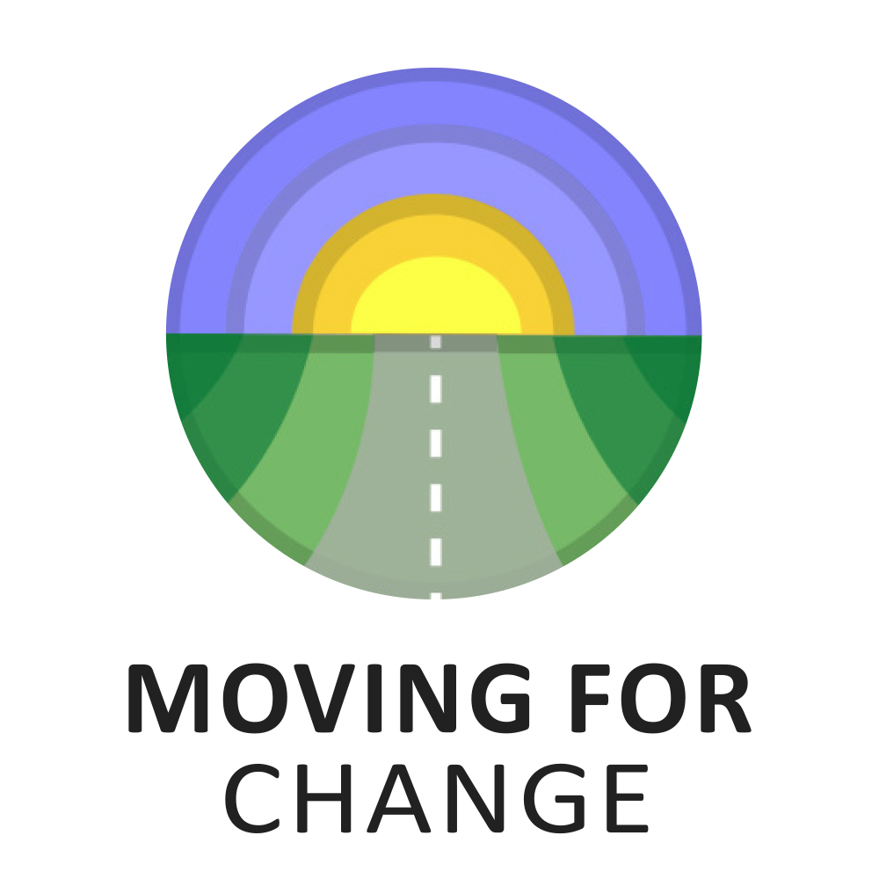

For commissions up to £500

COMMISSIONING AND TENDERING
GYPSY, ROMA, TRAVELLER HISTORY MONTH 2023

APPLICATION FORM

application form
Themes for this call:
Moving for Change is looking to commission 20 small intergenerational oral/visual history projects [up to £500 per project].
By intergenerational we mean young people interviewing parents/grandparents/elders on topics that the young people see as important to them. For example: young people might want to ask how the older generations managed to put food on the table and/or heat trailers during hard times – how did they make ends meet on limited incomes, or how has travelling/shifting changed over the generations, or what sort of education did older generations have – did they attend school and so on. Essentially, we are looking to commission projects that clearly demonstrate how despite the many challenges Gypsies, Roma and Travellers face; their strong ties to family and the land have always seen them overcome these challenges and continue to live their way of life. Projects can be produced in video, podcast, storyboard or booklet format.
All projects must take place during Gypsy, Roma, Traveller History Month and, to allow time for editing, the final product must be sent to Moving for Change by end July 2023.
Who can apply for this funding?
This call is open to all Gypsies, Roma and Travellers and organisations directly supporting the communities. You do not have to be a member of the Moving for Change network to apply [although it would be nice if you did sign up, you can do so here]. The closing date for applications is Friday 19th May at 5pm and we will let you know the week after the closing date if your application has been successful. If successful, we will ask you for bank details to send the project money to you.
What Moving for Change needs from you
As we are commissioning just 20 projects, and we expect number of applications to exceed this amount, your project is more likely to be selected if you provide a clear picture of what you are planning to do and what the benefits of your project will be to the participants. In terms of benefits, we will be looking for things like improving relationships and understanding across the generations or young people learning more about their community’s history of travelling/shifting.
We will ask successful applicants to provide videos, podcasts and/or images of the funded Gypsy, Roma, Traveller History Month event. We will ask anyone in the footage to fill out a simple consent form to have their images used by Moving for Change.

Section 1: Tell us about you

Your name and address:
Name
Address

Post code
Telephone
Email

Independent referee:
Provide details of an independent referee who knows you well enough to give you a character reference.
Name
Organisation
Telephone
Email

Section 2: Tell us about your project
[Remember to give a clear picture of what your project will look like and what benefits you think there will be for those taking part].
Tell us about your plans for the project in no more than 750 words. If you prefer you can send us a voice recording or a video for this section you can send this via WhatsApp to 07873 904738.

Section 3: Budget
Please tell us how you would use the funds if you were successful. Include all the costs.
Costs | Amount from us (£)
Example: Hire of video camera or travel costs
Total

Section 4: Where did you hear about this funding opportunity?
Please mark an X to all that apply:
- Twitter
- Instagram
- Our website
- Through a friend or family
- Through a colleague
- Through a service or Gypsy, Roma or Traveller organisation
- Search engines such as Google or Bing
- The Travellers Times
- Other- please specify…………………………………………………………………………………………….

Section 5: Declaration
I am applying for [Insert the amount you are applying for] which I will spend on the activities I have outlined above. I confirm that the information given in this form is true and accurate. I authorise Moving for Change to hold any information supplied about this application in its electronic or manual records and that the information supplied can be used for the purposes of assessment, publicity, or promotion of any award or passed on to other relevant third parties without the need for further consent to be obtained.
Name: | Signature: | Date:

Section 6: Submitting your application
Please send this form to contracts@movingforchange.org.uk with your name and the commissioning theme [Gypsy, Roma, Traveller History Month Intergenerational Project] in the subject line of the email. Please save this form with your name and the project theme as the file name. Receipt of your application will be acknowledged.

